

**AKVA网箱水下投饵系统**

An effective feeding system that provides increased growth

and improved fish welfare.

高效的投饵系统保证了鱼类的饲养环境及稳固增长

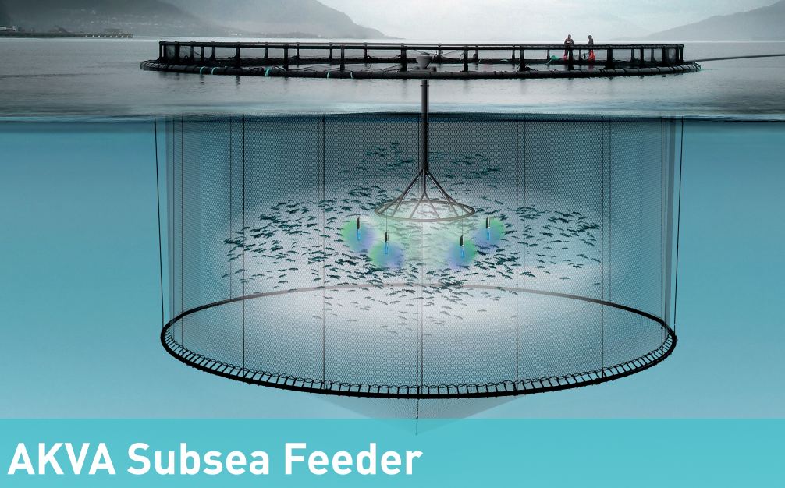

AKVA Subsea Feeder is an underwater feeding system

that feeds fish at a depth of approximately eight metres.

The feed is transported to the cages through a regular

air hose. Water is added and passed down through a

main pipe. The water is added by using a pump that

draws deep water of good hygiene, in order to ensure

the required speed of the feed. The feed is then spread

using a dispersion unit of 17 meters in circumference

with 12 feeding units so that the feed is spread about

the cages in a satisfactory manner. The feeding rate

is up to 50kg of feed per minute. Experience from

using the system shows the need for bird netting is not

required.

挪威Akva集团公司是挪威渔业养殖的领导者，其开发的水下投喂机在水下约8米的水深工作，由气泵将饵料吸入，加之较深海水的混合，再由泵将充分混合的饵料传送至水下17米周长的12个投饵口，喂食率高达50kg每分钟。这种深水投饵方式可以确保饵料的均匀分散、养分高、保护鱼类免受寄生虫的困扰，同时也不用设置防鸟的装置以防争夺饵料。

投饵系统图示：

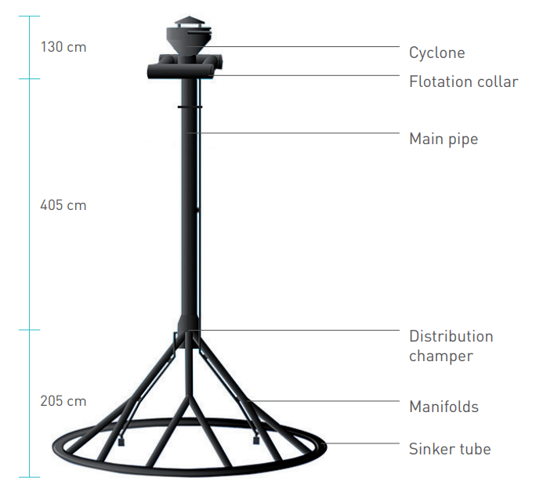

该系统符合NS9415条律

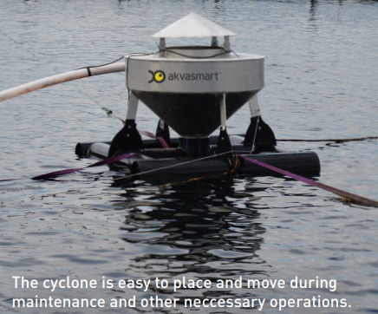

**系统参数：**

**-总重量：570kg**

**-饵料投喂器周长：17米 直径5.5米**

**-投饵口：12个**

**-投喂速度：50~60kg每分钟**

**-深度：约等于8米**

**- 材料：PE**